*Florida International University*

*School of Computing and Information Sciences*

Software Engineering Focus

Feature Document

User Story #**230 - Create an HMD Game Framework**

**Team Member:**

Jacob Leschen

**Product Owner(s)**:

Francisco Ortega

**Mentor(s)**:

Mohsen Taheri

**Instructor**: Masoud Sadjadi

**User Story** Implement a game in Unity that takes advantage of all HMD features and can be used for educational purposes

* As a user, I would like to have a game using the HMD, so that the features implemented can be put to a functional use.

Acceptance Criteria

* Game uses HMD and controller functions
* Game has a defined win state and lose state
* Game can be implemented and finished in time for final presentation

**Use Case Diagram**

Untitled Diagram (6).png

**Sequence Diagram**

Untitled Diagram (8).png

**Class Diagram**

Untitled Diagram (7).png

**Unit Test**

Test case: Win Condition

Purpose: Test to see if win animation plays when key triggers the collider

Preconditions: Win condition has no other objects touching it

Action: User places the key item on the win condition box

Expected result: Yellow light should activate in an animation that increases its intensity

Actual Result: same as expected

Test case: Key gates

Purpose: Assure that gates can only fit the associated key item; user gates can only let user pass

Preconditions: User has the key item in hand

Action: user presses the teleport button, points to a location, then releases it if the color is green; User attempts to fit the key item into the hole

Expected result: User should teleport to the location. If passing through a transparent purple slot, the key item should be dropped; Key item should fit only into the associated shaped hole

Actual result: same as expected

**Visual User Guide**

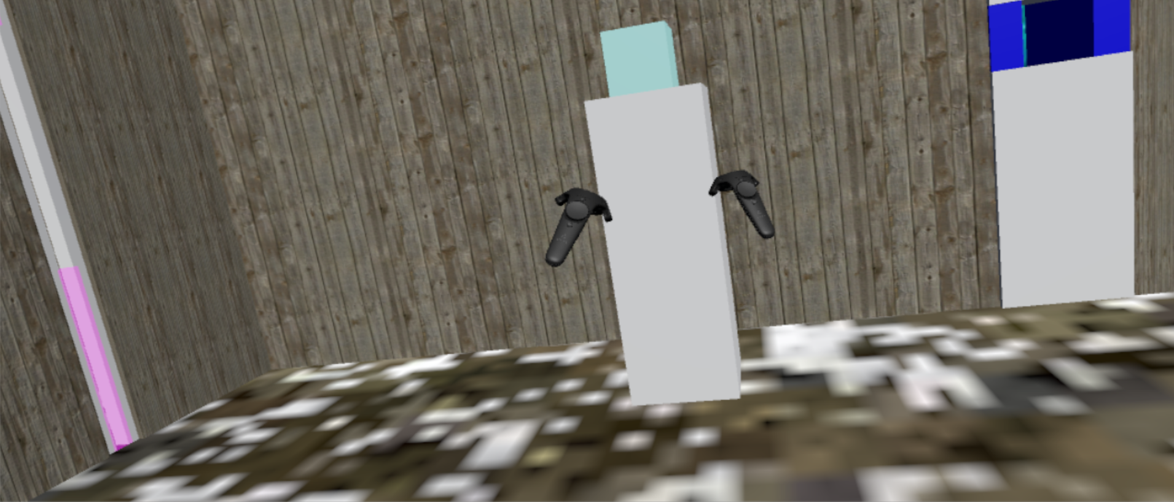

User must pick up the teal cube and carry it through the maze. Blue holes can fit the cube, green holes can fit the flat box, and purple holes are for the user to teleport through. Each hole is mutually exclusive.

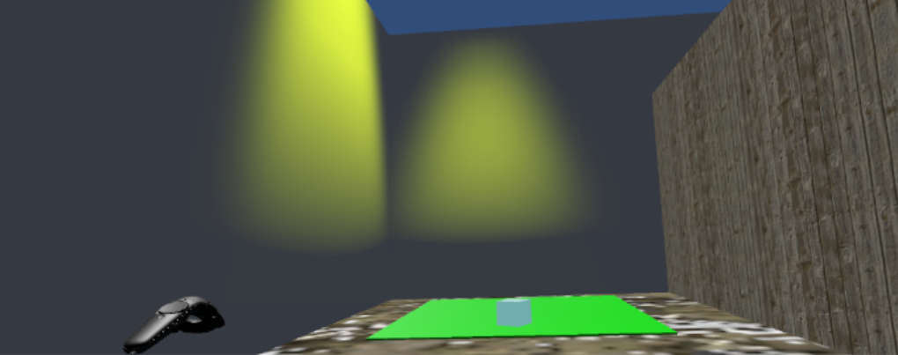The goal of the game is to get the key item to the green square at the end of the maze